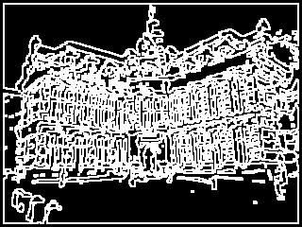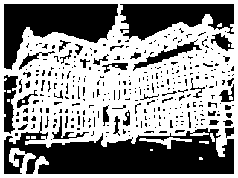**INFOIP Image Processing - Assignment 2**

Figure 3 This is picture Z

## Part 1: What is shown in Image Z.

Figure 2 This is picture Y

Figure This is picture X

By taking the AND of the image X and complement Y, you get the image Z. Where Z is then the difference between the dilation and erosion of A. In total, the whitespace we see on image Z is the area that has either been dilated or eroded from the original image, so basically the changes that have been imposed on it.

## Part 2: The relation between the structuring element and the distinct values.

When the kernel size is increased a clear decline in the count of distinct values can be observed. When taking the minimal value of an increasingly large kernel, it is more likely for ‘extreme’ high values to not be selected. And thus the count of distinct values in the image decreases.

Figure 4 X-axis: Square kernel size Y-axis: Distinct Values

## Part 3: Similarities and differences between the Fourier shape descriptors of Image G1, G2 and G3.

2 Fourier descriptors of G2 in scatter plot

3 Fourier descriptors of G3 in scatter plot

1 Fourier descriptors of G1 in scatter plot

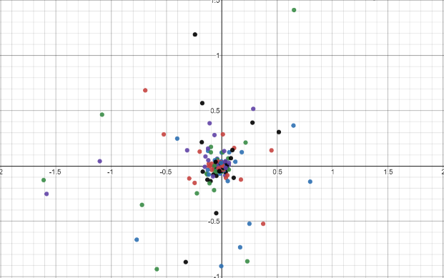

Looking at the scatter plots of the different images, they don’t look much alike. The only thing you could say is that most of the points are around (0,0). But when compared to the scatter plot of a completely different image (looks like a hockey stick), you see there is a resemblance between G1, G2 and G3. Because the last scatter plot has a vastly different shape than the other images and the scatter pattern does not match the pattern of the seahorse images.

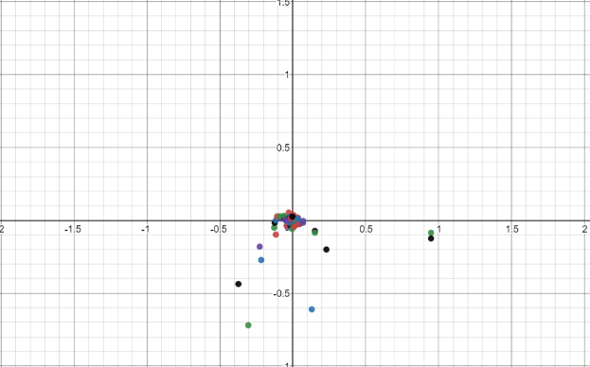

4 Fourier descriptors of different shape in scatter plot

## Note:

After handing in our previous assignment, there were a few flaws in our code. The flaw was in the edge detection filter, we incorrectly implemented the Sobel filter. After the grading, we corrected the code and created the new image B. As is shown below:

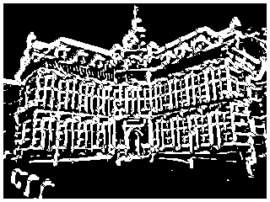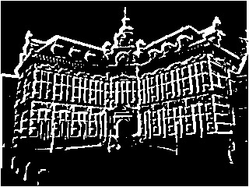

New image B (threshold 3)

Old image B (threshold 18)